New Rittal RiMatrix Data Center configurator
Rittal data centres now configurable online
Herborn, 2025-08-27.
IT is now a part of almost every aspect of life and the economy. Various industries are still in the early stages of adopting AI applications, but these will really take off in the coming years. The industrial sector is particularly active in the field of industrial AI, as these technologies not only speed up processes but also unveil new economic opportunities. All of this requires computing power. A lot of it. New IT infrastructure must grow rapidly. Existing data centres must be expanded. Rittal is making the path to this goal quicker and easier with a new online configurator.

The planning effort required for a data centre expansion is enormous. Data centres are complete systems in which racks, power, cooling, monitoring and security mechanisms are interlinked and must therefore be planned in relation to one another. The requirements in projects are becoming increasingly specific. Rittal now makes planning and designing easier for customers with the RiMatrix Data Center configurator, available online 24/7.

With just a few clicks, users can get a configuration that has all the essential elements of the RiMatrix platform, and it will meet their specific requirements. The intuitive tool allows you to quickly plan racks, power, cooling, monitoring and security mechanisms. Intelligent algorithms immediately check the selected configurations for feasibility. Using 3D imaging, customers can see a realistic visualisation of their individual solution, including a complete parts list. The tool also offers the option of requesting a quote directly.

“The new configurator is not intended to replace consulting. We will continue to draw on our experts’ many years of experience to provide our customers with reliable IT infrastructure,” says Carina Schmidt, Solution Sales IT at Rittal: “It’s about providing an additional service that allows customers to quickly obtain a plausible initial overview at any time.”
With one click, you can request a callback for advice, where you can get straight down to business. This is because the key data is already available thanks to online configuration.

You can find the configurator here.

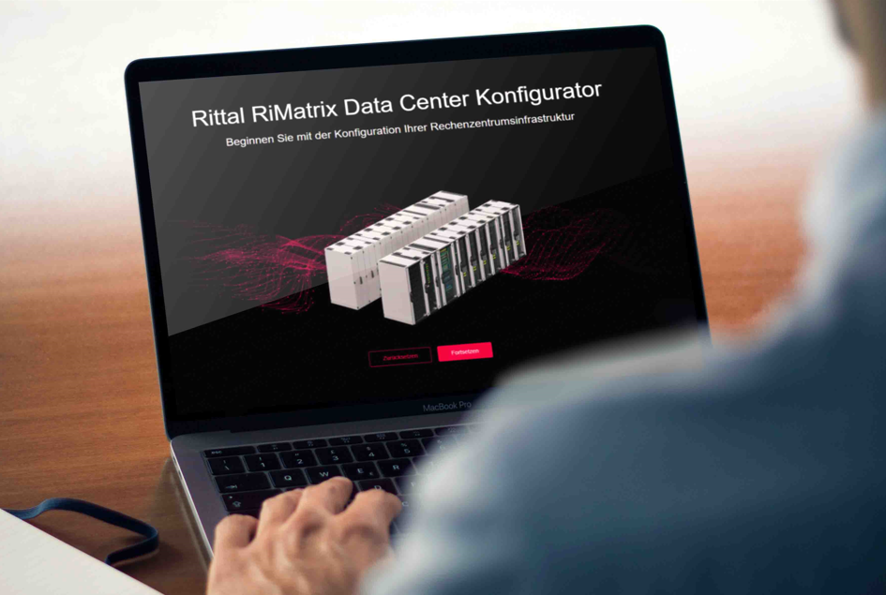 |  | 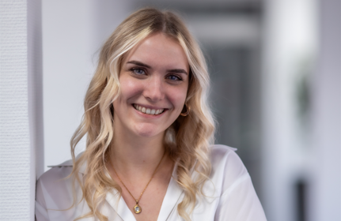
The RiMatriX Data Center Configurator allows to quickly plan racks, power, cooling, monitoring and security mechanisms. |  | Carina Schmidt, Solution Sales IT at Rittal

May be reproduced free of charge. Please name Rittal GmbH & Co. KG as source.

Rittal

Rittal is a leading global supplier of enclosure systems, automation and infrastructure with its industrial, IT, energy and power, cooling and service units. Rittal products and solutions are used in over 90% of global industries – standardised, customised, and always of the very best quality.

Our approach and methodology: Rittal, Rittal Software Systems (Eplan, Cideon) and Rittal Automation Systems (RAS, Ehrt, Alfra) combine their hardware and software expertise to streamline, optimise and industiralise processes across the entire value chain of their customers including their IT infrastructure – from control and switchgear construction, machine building to manufacturing companies or the energy sector.

Our delivery promise: Rittal standard products are delivered in Germany within 24 hours, and within 48 hours throughout Europe.
Customer focus
Improving efficiency and increasing productivity through automation and digitalisation is one of the biggest challenges for our customers. This requires in-depth knowledge and expertise, the combination of hardware and software, and cross-sector networking. We are convinced that creating and connecting data rooms is crucial to the success of industrial transformation. And that is exactly our speciality and field of competence.

Eplan and Rittal are driving the development of the digital automation twin, making data accessible and useable in operations as well. Cideon is improving data consistency in the digital product twin context with its CAD/CAM, PDM/PLM and product configuration expertise.
Sustainability
Environmental and climate protection, social commitment and ethical corporate management are a given for Rittal. We take our responsibility for a sustainable future seriously. Our approach to resource management and conservation involves continuous improvement of our own production processes and ensuring that our products have the lowest possible Product Carbon Footprint. Our solutions support our customers in achieving their own climate targets.
Family business and global player
Founded in 1961, Rittal is the largest company in the owner-operated Friedhelm Loh Group. The group operates worldwide, with 13 production sites and 95 international subsidiaries. It has 12,600 employees and posted revenues of 3.1 billion euros in fiscal 2024. In 2023, the Friedhelm Loh Group was presented with the “Best Place to Learn” and “Employer of the Future” awards. In 2024, Rittal was awarded the Top 100 Seal as one of Germany’s most innovative medium-sized companies for the third time in a row.
For more information, visit www.rittal.com and www.friedhelm-loh-group.com.

Corporate Communications
Dr. Carola Hilbrand Rittal GmbH & Co. KG
Corporate & Brand Communications Auf dem Stützelberg
Tel.: 02772/505-2527 35745 Herborn
hilbrand.c@rittal.de www.rittal.com

